**Data Structures and Algorithms**



Session: 2022 – 2026

**Submitted by:**

Muhammad Saad Akmal        2022-CS-148

**Submitted To:**

Mr. Muhammad Faraz

Department of Computer Science

**University of Engineering and Technology**

**Lahore Pakistan**

**Experiment**

# **Incrementing By 1:**

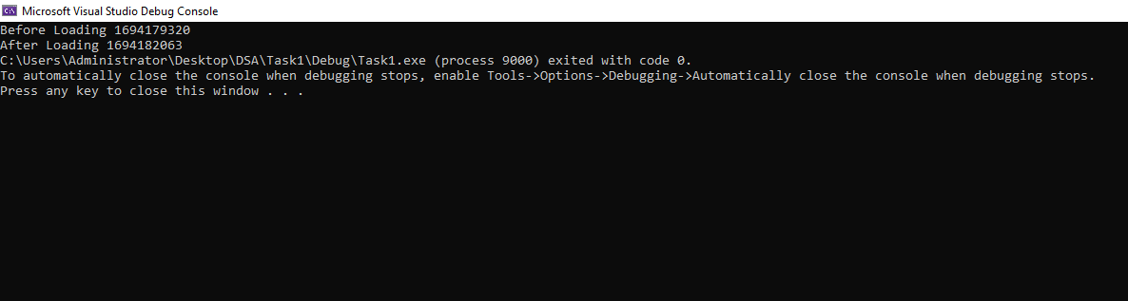

## **Explanation:**

When the capacity of array is incremented by one it took almost 45 minutes or 2730 seconds to push back the data of 2Mb.

# **Incrementing By factor of 2:**



## **Explanation:**

When the capacity of array is incremented by factor of 2 it took only 4 seconds to push back the data of 2Mb.

# **Incrementing By factor of 1.5:**



## **Explanation:**

When the capacity of array is incremented by factor of 1.5 it took only 3 seconds to push back the data of 2Mb.

## **Conclusion:**

By conducting the experiment it was seen that by incrementing the capacity by 1 too a lot more time as compared to incrementing by factor of 1.5 and 2.Thus incrementing by 1.5 and 2 is considered as best approach for implementing growable arrays.